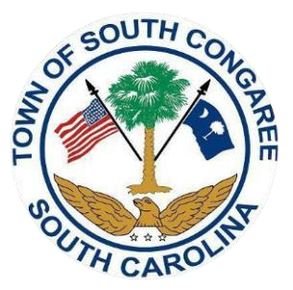
South Congaree Town Council
2023-2024 Budget Special Called Meeting
Tuesday, June 27, 2023, 6:30 pm
South Congaree Town Hall Council Chambers
119 West Berry Rd., West Columbia, SC 29172

- Call to Order 6:30 pm
A. Roll Call and Determination of Quorum
B. Pledge of Allegiance
C. Invocation
D. Freedom of Information Act Compliance

- SECOND AND FINAL READING
Ordinance 2024-01: Fiscal Budget.
PURSUANT TO SOUTH CAROLINA CODE OF LAW SECTION 5-7-260.
AN ORDINANCE FOR THE TOWN OF SOUTH CONGAREE, SOUTH CAROLINA FOR THE
ESTABLISHMENT OF A MUNICIPAL BUDGET FOR THE FISCAL YEAR 2023-2024; AND ALL OTHER MATTERS RELATED TO THERETO.

III. Public Comment(s): (Varies upon attendee’s request, three minutes per person)

IV. Executive Session
S.C. Code 30-4-70 (A) (1) Discussion of employment, appointment, compensation, promotion, demotion, discipline, or release of an employee, a student, or a person regulated by a public body or the appointment of a person to a public body. [Personnel]

Upon returning to open session, action may be taken by Council regarding matters discussed in the Executive Session.

V. Adjournment

The public was duly notified of the date, time, and place of the upcoming meeting. The Town of South Congaree is a handicapped accessible facility.

