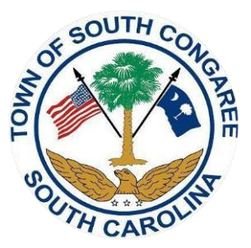
South Congaree Town Council
2023-2024 Budget Public Hearing
Tuesday, June 27, 2023, 6:00 pm
South Congaree Town Hall Council Chambers
119 West Berry Rd., West Columbia, SC 29172

- Call to Order 6:00 pm
A. Roll Call and Determination of Quorum
B. Pledge of Allegiance
C. Invocation
D. Freedom of Information Act Compliance

- PUBLIC HEARING
Ordinance 2024-01: Fiscal Budget.
AN ORDINANCE FOR THE TOWN OF SOUTH CONGAREE, SOUTH CAROLINA FOR THE
ESTABLISHMENT OF A MUNICIPAL BUDGET FOR THE FISCAL YEAR 2023-2024; AND ALL OTHER MATTERS RELATED TO THERETO. THE AFFIDAVIT OF PUBLICATION AND PUBLIC NOTICE WAS ADVERTISED ON JUNE 12, 2023 PURSUANT TO SOUTH CAROLINA CODE OF LAW SECTION 5-7-260.

III. Public Comment(s): (Varies upon attendee’s request, three minutes per person)

- Adjournment

The public was duly notified of the date, time, and place of the upcoming meeting. The Town of South Congaree is a handicapped accessible facility.

